各通道数据可视：

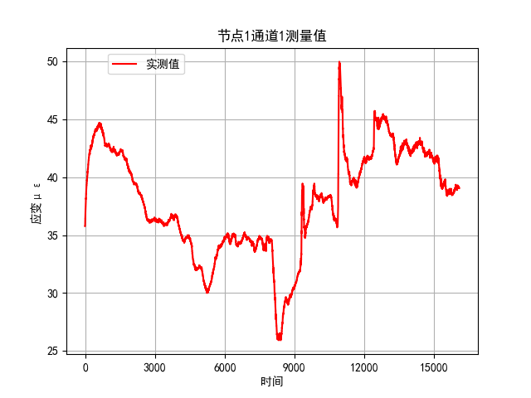

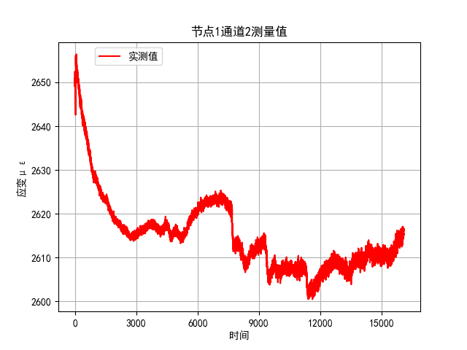

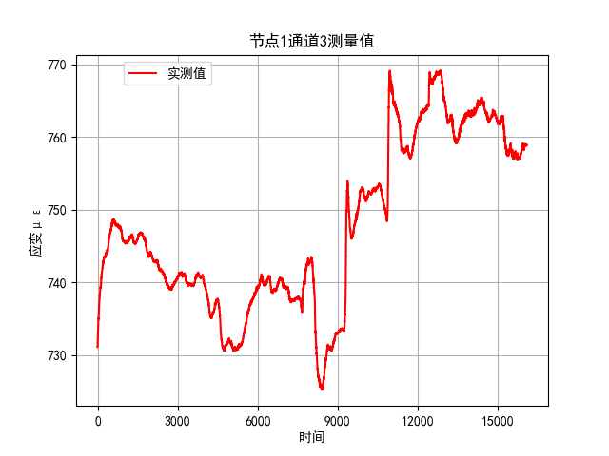

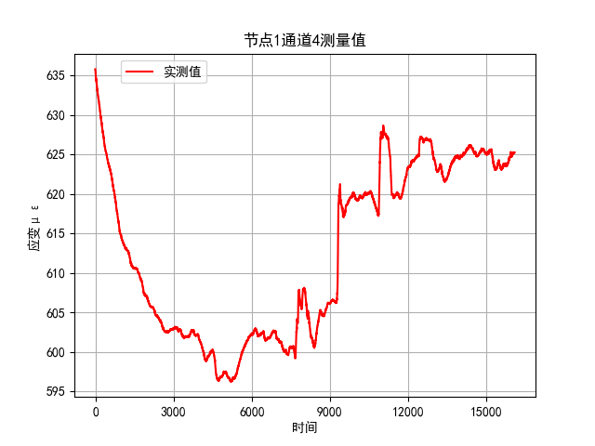

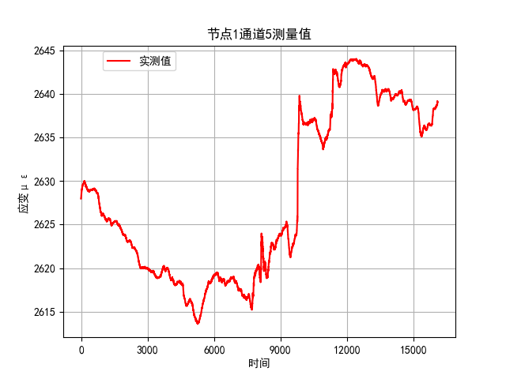

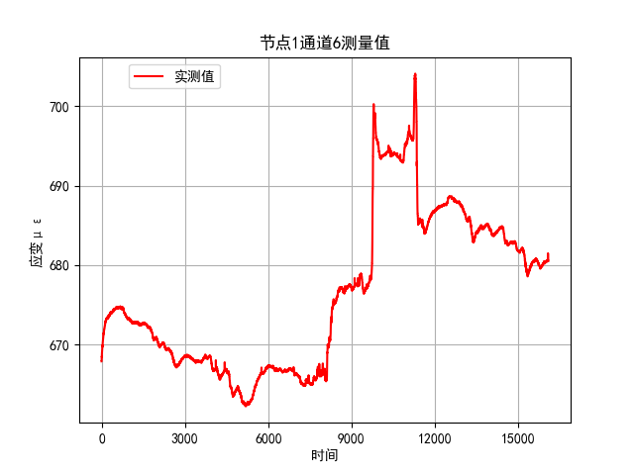

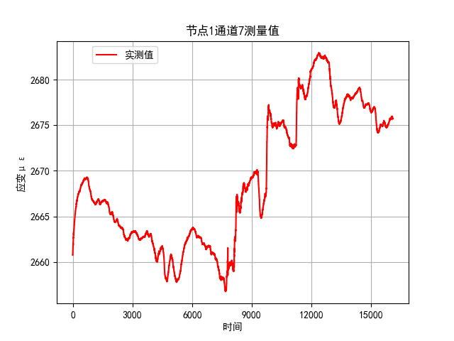

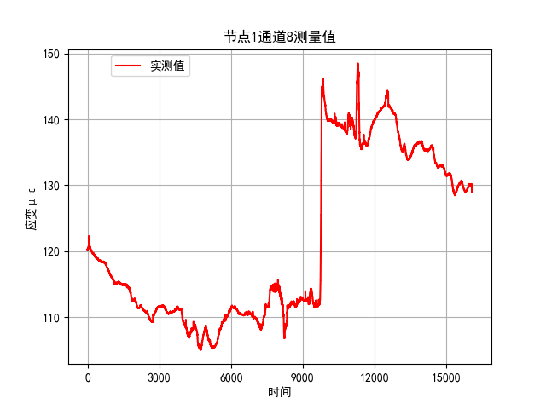

各传感器位置：

○为测试设备

▽为三智设备

|  |  |  |  |  |  |  |
| --- | --- | --- | --- | --- | --- | --- |
| 三智数据，单位με | 1 | 2 | 3 | 4 | 5 | 6 |
| 浇筑前(绝对值) |  | 3353 |  | 3010 |  | 2578 |
| 浇筑后(绝对值) |  | 3477 |  | 3065 |  | 2671 |
| 浇筑前(相对值) |  | 0 |  | 0 |  | 0 |
| 浇筑后(相对值) |  | 124 |  | 55 |  | 93 |

